**Lab Notebook Table of Contents**

|  |  |
| --- | --- |
| Week 1: Week of June 5th | Pg. 2 - 4 |
| Week 2: Week of June 12th | Pg. 5 - 8 |
| Week 3: Week of June 19th | Pg. 8 - 10 |
| Week 4: Week of June 26th | Pg. 11 - 13 |
| Week 5: Week of July 3rd | Pg. 14 - 16 |
| Week 6: Week of July 10th | Pg. 17 - 20 |
| Week 7: Week of July 17th | Pg. 20 - 23 |
| Week 8: Week of July 24th | Pg. 24 - 26 |
| Week 9: Week of July 31st | Pg. 27 - 31 |
| Week 10: Week of August 8th | Pg. 32 - |

**Week 1: Week of June 5th**

* June 5th, 2017
  + Attended Orientation for the Undergrad research program. (~1.5 hours)
  + Attended Orientation for the BMS Undergrad Research Lab Procedures. (~2 hours)
  + Reinstalled Python on laptop according to tutorial specifications. (~2 hours)
    - Installed and configured Visual Studio Code for Python on my laptop.
      * (currently only using Python 3.6, though this may change)
      * (not certain if Python is needed for project yet)
  + Started the “Building your first app” tutorial from Google. (~2 hours)
    - <https://developer.android.com/training/basics/firstapp/index.html?hl=p>
    - Completed the sections “Create an Android Project” and “Run your App”
      * The app worked according to the tutorial at this point.
* June 6th, 2017
  + Read a recent article about safety apps in India (~1 hour)
    - <http://timesofindia.indiatimes.com/city/bengaluru/safety-apps-do-not-guarantee-refuge-in-troubled-times-study/articleshow/58943591.cms>
  + Wrote the first article review about the above article according to specifications (~1.5 hours)
  + Completed the “Building your first app” tutorial from Google, the “Build a Simple User Interface” and “Start Another Activity” sections. (~1.5 hours)
    - I only found it helpful as a base to get started on Android development. It sort of glossed over some concepts of Android and some parts plain didn’t work as suggested in the tutorial, plus the app didn’t actually end up working as expected despite following the tutorial closely.
  + Started reading the Vogella Android development tutorial (~2 hours)
    - <http://www.vogella.com/tutorials/Android/article.html#high-level-overview-of-android-development>
    - Finished parts 1 - 7, may need to reread some parts later
  + Looked up what “Kotlin” language is since referenced in above guide (~1 hour)
  + Updated Lab Notebook to today from empty (~0.5 hours)
* June 7th, 2017
  + Finished Vogella Android development tutorial with exercises (~3.5 hours)
    - Reread parts 6 and 7, read from parts 7 to 15
    - Created simple app, temperature converter, app w/spinner, etc.
    - Found this tutorial to be more helpful, though still had to look up some facets of the program/language and it’s got a few confusing typos
  + Looked up some articles to read later on from searches for bluetooth (~0.5 hours)
    - <https://www.whathifi.com/advice/bluetooth-5-everything-you-need-to-know>
    - <https://www.wired.com/2010/09/wireless-explainer/>
    - <https://blog.bluetooth.com/exploring-bluetooth-5-going-the-distance>
    - <https://www.theverge.com/circuitbreaker/2017/5/26/15687670/bluetooth-5-anker-incipio-griffin-iphone-samsung-coming-soon>
  + Read four short articles on new bluetooth technology (~1.5 hours)
  + Read about Bluetooth API on Android Studio (~1.5 hours)
    - <https://developer.android.com/guide/topics/connectivity/bluetooth.html>
    - Found it helpful, though a little confusing still. May need to reread some of it to really understand it or actually try coding it into an actual product.
* June 8th, 2017
  + Read an article on smartphone ownership, only to find out that its data was actually more outdated than it let on, then realized that I may have had the wrong article saved and spent a bit of time looking for it again (~0.5 hours)
  + Read the actual/non-bugged articles about smartphone ownership statistics (~0.5 hours)
    - <http://www.pewinternet.org/fact-sheet/mobile/>
    - <http://www.pewresearch.org/fact-tank/2017/01/12/evolution-of-technology/>
  + Reread the Bluetooth API Guide (~1 hour)
    - Have a slightly better idea on the matter as of now, still need to actually code this to really get a grasp
  + Looked up projects and existing products with similar elements made using things like Arduino boards for ideas (~1 hours)
    - Includes things like Flic, Wise Button, Camera Remotes, Light Switches, LifeAlert-like systems etc.
    - Really not sure about actually implementing bluetooth communication between devices as of now.
  + Toured NYU Makerspace and received training for 3D Printers (~1 hour)
  + Additional research on Bluetooth, including basic articles about the general workings and reasons for failure (~1 hour)
    - <https://www.digitaltrends.com/mobile/how-does-bluetooth-work/>
    - <http://www.explainthatstuff.com/howbluetoothworks.html>
    - <https://learn.sparkfun.com/tutorials/bluetooth-basics>
      * Learned about Bluetooth profiles, HID might be the one to go with for this project
    - <http://www.techlicious.com/how-to/how-to-fix-bluetooth-pairing-problems/>
  + Learned about NYU Library resources and ways to do research for a particular topic (~1.5 hours)
  + Looked for more articles on Android Studio Bluetooth implementation to read later on, found a guide more concise and a bit more informative than the other one on the API and a scanner tutorial (~0.5 hours)
    - <http://www.androidauthority.com/adding-bluetooth-to-your-app-742538/>
    - <https://code.tutsplus.com/tutorials/create-a-bluetooth-scanner-with-androids-bluetooth-api--cms-24084>
* June 9th, 2017
  + Read the androidauthority Bluetooth API guide (~1.5 hours)
    - Found it about as helpful, if not a little more so, than the other guide, but the importance of actually practicing this in code can’t be stressed enough
  + Looked up some terminology like “Toasts” and “Intent Filters” (~0.5 hours)
    - Kind of considering just doing a Java course right now
  + Installed Eclipse for Java development practice (~0.5 hours)
  + Started Java tutorial parts 1 - 21 <https://www.youtube.com/playlist?list=PLS1QulWo1RIbfTjQvTdj8Y6yyq4R7g-Al> (~ 4 hours)
    - Unsure if I need the entire thing right now, but will at least watch to get some idea on how to read Android Studio code since it’s Java-based
    - Tutorial also seems kind of old, but doesn’t seem horribly dated right now
    - Not sure if this is helpful at all actually, but seems nice to know anyway
  + Found/Watched a tutorial on writing android apps from Android Authority https://www.youtube.com/watch?v=mAJeK283j0I (~0.5 hours)
    - Was pretty helpful in going over what the different files did
* June 12th, 2017
  + Tried viewing an Android Studio tutorial on YouTube since I thought the text version needed some supplementing (~ 2 hours)
    - Final app in this tutorial didn’t seem to have a proper layout when loaded
    - Probably because guide is somewhat outdated to Android Studio version
    - Did learn a little bit on how to color certain elements
  + Read up on how to change the parent layout in Android Studio because that was kind of confusing in the few tutorials that require that change to be made (~ 0.5 hours)
  + Reread some of the code made from previous tutorials to brush up and see what their layouts are (~0.5 hours)
  + Started a bluetooth tutorial parts 1-3 (~4 hours) <https://www.youtube.com/watch?v=y8R2C86BIUc&list=PLgCYzUzKIBE8KHMzpp6JITZ2JxTgWqDH2>
    - Found tutorial very helpful, but part 3 is causing me a bit of trouble
* June 13th, 2017
  + Read a few articles on Bluetooth and Wireless, Internet of Things (~1 hour)
    - <https://www.wired.com/2010/09/wireless-explainer/>
      * Interesting look at how signals can interfere with each other and why the regulations we have today are in place for routers
    - <https://www.whathifi.com/advice/bluetooth-5-everything-you-need-to-know>
      * About the same as other “Bluetooth 5 details” articles
    - <https://www.theverge.com/2017/6/12/15783170/wireless-anti-theft-tracking-devices-roambee-latent>
      * Seemed helpful and went over the methods used to track stolen products through bluetooth and other wireless, but bluetooth isn’t mentioned much despite being in the title
    - <https://www.usnews.com/opinion/economic-intelligence/articles/2017-06-12/dont-stifle-the-internet-of-things-with-regulation>
      * Interesting look into the risks of security with the Internet of Things, but found a lot of this to be kind of political rhetoric?
  + Open Lab Work check in (~0.5 hours)
  + Found and read a journal on Bluetooth, wrote first article review this week about it (~1.5 hours)
    - Realized that the article review I wrote last week was invalid because it wasn’t about a peer-reviewed journal, needed to find a new one.
  + Looked over the code from the previous tutorial to see what was wrong with the version I typed out, and doing a little more extensive testing (~2 hours)
    - Forgot to mention this, but apparently the emulator in Android Studio doesn’t let you actually try out Bluetooth, so I’m gonna be using my actual phone for testing
    - This part also needs a bluetooth device to actually test it with, and I have none of those, so I’m gonna see what I can do about that
    - Still need to figure out how to properly lay out buttons and stuff because most of these apps have become jumbled messes as of yet
  + Looked up what “Gradle” was finally, since it’s mentioned in Android Studio a whole bunch (~0.5 hours)
    - <https://stackoverflow.com/questions/16754643/what-is-gradle-in-android-studio>
  + Tried looking for more related articles, but got “researcher’s block” I guess, could only find a couple more that I could read on the subject. Did see some more examples of physical implementations of bluetooth though like credit card skimmers and the like (~0.5 hours)
    - <http://whnt.com/2017/05/14/bluetooth-users-watch-out-for-bluesnarfing/>
    - <https://www.gadgethacks.com/news/us-release-grabs-panic-button-feature-could-mean-safer-rides-0178103/>
  + Read the above articles (~0.5 hours)
  + Tried fixing the layout more in the practice code, still can’t get it down right (~0.5 hours)
    - May need to do a tutorial again
* June 14th, 2017
  + Tried to find bluetooth devices to test this tutorial app with, but couldn’t find any surprisingly (~0.5 hours)
  + Looked for more journals to write about, found one that might be helpful (~0.5 hours)
  + Did the bluetooth tutorial parts 3-5 (~6.0 hours)
    - Finished up a basic bluetooth app which can enable/disable bluetooth, activate discoverable mode, and also enable discovery of other devices (This part wasn’t really tested yet)
    - Started work on a bluetooth chat app with lets two phones with the app talk to each other
    - Ran into quite a few issues with the code during the tutorial and had to scour the app(s) for the problems
      * Still actually have a few issues with the second app the tutorial had me make, will need to look those over again
    - Starting to sort of understand this, but I really need an external BT device to test this with.
* June 16th, 2017
  + Looked up some more scholarly journals to read/write about later, found about 4 that seem useful to the project (~1 hour)
  + Was provided the actual button to be used for the panic button, looked up the model and its functions (~0.5 hours)
    - It’s a KobraTech Bluetooth Remote Shutter Release model?
    - Works up to 30 ft apparently
    - Bluetooth 3.0
    - Battery ran out before I could actually do any testing with it, need to ask for another one
  + Finished up the above bluetooth tutorial (~1 hour)
    - Overall very helpful at first, but the last few parts kind of went over my head
    - I don’t imagine the last few parts to be especially vital at the moment since they dealt with full-on data communication instead of simple communication
  + Waited for Android Studio package updates/Started adding Google Play Services to Studio (~0.5 hours)
    - <https://developers.google.com/android/guides/setup>
  + Tried to find Mackenzie to get a new battery for the button, but couldn’t find her (~0.5 hours)
  + Watched this tutorial on getting a person’s location on Android, but I feel like it’s sort of outdated since some of the methods/classes/syntax is different from my version of Android Studio (~2 hours)
  + Wrote second article review for the week (~1.5 hours)
* June 16th, 2017
  + Started part of a different tutorial for an app which gets the user’s last known location (~2 hours)
    - <http://en.proft.me/2017/04/17/how-get-location-latitude-longitude-gps-android/>
  + Attended Presentation by former research-program participant (~1.5 hours)
    - Found it pretty helpful, plus got to talk to a few people
  + Laptop didn’t start correctly from hibernation, had to hard reset it but lost the location of the tutorial in the process since I forgot to take it down somewhere so I had to search for it for a while (~0.5 hours)
    - Found other tutorials which may help though.
  + Finished the rest of the tutorial, but the app’s APK wouldn’t download onto the emulator (~1 hour)
  + Started a tutorial, but then had to install Google Services APIs as part of it, realized I ran out of space on the C Drive and had to transfer stuff over to my other drive (~1 hour)
    - <http://blog.teamtreehouse.com/beginners-guide-location-android>
    - Attempted to move over some SDK files but then stuff just stopped working
  + Reinstalled Android Studio and did all manner of troubleshooting because stuff just kept on not working (~1.5 hours)
    - Okay, now nothing works, great. Just love when this happens.
* June 17th, 2017
  + Continued troubleshooting Android Studio (~2 hours)
    - Realized that since I had moved stuff over drives, I had to clean/rebuild/make APK of all the projects I moved over
* June 19th, 2017
  + Updated the Lab Notebook with articles I had searched for in prior weeks (~0.5 hours)
    - Sort of had to search for them again, but found them relatively quickly
  + Did this tutorial on Google Maps API/Location (~2 hours)
    - <https://www.androidtutorialpoint.com/intermediate/android-map-app-showing-current-location-android/>
    - Basic Google Maps app worked after some deliberation, but tutorial after that wasn’t very helpful and seemed to skip over a lot
  + Took a look back at that Bluetooth test app I made with the tutorial (<https://www.youtube.com/watch?v=hv_-tX1VwXE&index=3&list=PLgCYzUzKIBE8KHMzpp6JITZ2JxTgWqDH2>) to see if it worked, but found out that parts of it were actually plain wrong and caused the app to crash or not work in the intended way, tried to fix it (~4.5 hours)
    - Majority of this time was watching the tutorial, looking through the provided source code, and continually restarting/trying out the app
    - Have isolated the problem, but can’t find a solution still
    - Only 2/3 pieces of the app work properly
* June 20th, 2017
  + Read up on some Android API documentation for things like Intents/Intent Filters, Location services, Intents, Contexts, etc. (~1 hour)
    - Sort of worried I actually don’t understand/retain the information from the tutorials, will do more reading into the documentation for these test apps if I ever get them working in the near future that is.
  + OLW Check-in (~0.5 hours)
  + Finished troubleshooting the bluetooth app, works about correctly now (~2.5 hours)
    - The tutorial had some outdated information so the “this.checkSelfPermission(‘~~~~’)” actually had to be an “ActivityCompat.checkSelfPermission(this,’~~~’)”.
    - Could still look into making improvements and actually understanding this code better though.
  + Read more Android API documentation, this time on Activities, rewatched some of the BT App tutorial to understand the code a bit better (~1 hour)
  + Laid groundwork for another tutorial on allowing apps to make phone calls (~1 hour)
    - <https://www.youtube.com/watch?v=SdqEdyM8s7o>
  + Wrote first article review for this week (~1 hour)
* June 21st, 2017
  + Finished up the Phone Call Test App, fixed some stuff using this tutorial <https://www.tutorialspoint.com/android/android_phone_calls.htm> (~0.5 hours)
  + Tried using this tutorial and the code it has to learn about SMS sending apps, but it didn’t seem to work correctly in the end (~2 hours) <https://www.tutorialspoint.com/android/android_sending_sms.htm>
  + Did this tutorial on SMS sending, and the app actually works too. Has a little explanation on how things work, but probably need to read more about it (~2.5 hours)
    - <https://www.androidtutorialpoint.com/basics/send-sms-programmatically-android-tutorial/>
  + Attended Career Development Panel (~2 hours)
* June 22, 2017
  + Read some android developer documentation on Layouts, UI, constraints, etc. (~3 hours)
    - <https://developer.android.com/guide/topics/ui/declaring-layout.html>
    - <https://developer.android.com/training/multiscreen/adaptui.html>
    - <https://developer.android.com/training/constraint-layout/index.html>
    - <https://developer.android.com/training/appbar/index.html>
    - Will probably find these articles handy when actually laying out the app
  + Read the following articles to see if retooling a remote shutter or other bluetooth device with buttons to do some other function is possible and how it could be done. (~2 hours)
    - <http://android.amberfog.com/?p=415>
    - <https://stackoverflow.com/questions/26741854/how-does-a-remote-shutter-for-camera-work-on-android-ios>
    - <https://stackoverflow.com/questions/27324509/is-it-possible-to-listen-the-click-of-a-bluetooth-button>
    - <https://developer.android.com/guide/topics/connectivity/bluetooth.html>
    - <https://developer.android.com/guide/topics/media-apps/mediabuttons.html>
    - <http://www.barbatricks.com/en/android-en/remap-ab-shutter-3-selfie-remote/>
    - <https://developer.android.com/training/keyboard-input/commands.html>
    - <https://stackoverflow.com/questions/17819649/how-to-capture-key-events-from-bluetooth-headset-with-android>
    - <https://android-developers.googleblog.com/2010/06/allowing-applications-to-play-nicer.html>
    - Still confused on the programming aspect, though it’s definitely possible at least
  + Wrote second article review for this week (~1.75 hours)
  + Met with Professor Lee and discussed the project for a bit (~15 minutes)
    - Have a better idea on what’s expected of me this summer
* June 23, 2017
  + Read some more documentation on things like snackbars, data storage, getting contacts (~2 hours)
    - <https://developer.android.com/training/snackbar/index.html>
    - <https://developer.android.com/training/basics/data-storage/index.html>
    - <https://developer.android.com/training/contacts-provider/retrieve-names.html>
      * Had to read this one over a few times, but still don’t entirely get it for some reason
  + Put together another test app, combining parts of the Bluetooth App and the SMS App (~5 hours)
    - User can insert (but not yet delete) contacts which are displayed into a list view
      * Current version only has numbers, names will need to be worked in later
      * Duplicates aren’t accounted for at the moment
    - Pressing a button sends a test message to those numbers in the list
    - Seems to work on a base level at least.
* June 26th, 2017
  + Read about Location Services again from the android developer’s guide (~1 hour)
    - <https://developer.android.com/training/location/index.html>
  + Waited for updates to Android Studio (~0.5 hours)
    - Read/reread some stuff about media buttons and android studio during that time.
  + Tried to fix some issues with the previous program made, could only manage to prevent duplicate contacts at the moment (~2 hours)
  + Attended presentation about diversity in STEM/combating bias (~1.5 hours)
  + Attempted to fix another problem with the previous program, eventually was able to make it so contact names are displayed with their number using the links/development notes below, though whether or not it’s the right way to do it is as of yet unknown (~2 hours)
    - <https://stackoverflow.com/questions/4613104/how-to-retrieve-contact-name-and-phone-number-in-android>
    - <https://developer.android.com/reference/android/provider/ContactsContract.html>
  + Found/Wrote review for a journal (~1 hour)
* June 27th, 2017
  + Looked at templates and started work on the first WIP (~1 hour)
  + OLW check in (~1 hour)
  + Looked over some old test apps, made sure they worked to some degree (~0.5 hours)
  + Worked on WIP 1 some more, think I have every slide there but need to check again to make sure (~2 hours)
  + Implemented the ability to delete contacts from the pre-prototype, fixed some other issues with names being displayed as well (~2 hours)
    - <https://stackoverflow.com/questions/11428168/removeviewview-is-not-supported-in-adapterview>
  + Updated the slides in the WIP to reflect today’s progress with the pre-prototype (~0.5 hours)
  + Read another journal article, will write about this later this week (~1 hour)
* June 28th, 2017
  + Looked over WIP 1 more, sent it in for earlier review but waiting on results (~1.5 hours)
  + Did some more reading, this time on the android app life cycle and storing information during this life cycle. (~2 hours)
    - <http://android4beginners.com/2013/06/lesson-0-9-android-app-life-from-oncreate-to-ondestroy-what-happens-when-we-start-app-and-what-are-activities/>
    - <http://www.jiahaoliuliu.com/2011/03/android-activity-life-cycle-from.html>
    - <https://developer.android.com/guide/topics/data/data-storage.html>
    - <https://stackoverflow.com/questions/8410259/saving-activity-state-in-the-onpause>
    - <https://stackoverflow.com/questions/16692536/good-solution-to-retain-listview-items-when-user-rotate-phone-and-keep-all-data>
    - A lot of this went over my head I think.
  + Fixed up the pre-prototype a bit, tried implementing some stuff I read about above, but didn’t really work. (~0.5 hours)
    - Unintentionally rolled back to the working version of the app out of habit, not sure if I want to present this for WIP 1 or not really.
  + Received feedback on WIP 1, edited it a bit more (~0.5 hours)
    - Added captions, references, cleaned up some wording
  + Briefly reread article, wrote second review about it (~1.5 hours)
* June 29th, 2017
  + Tried to keep contacts persisting between instances of the app, but still haven’t figured it out yet (~1 hour)
  + Lab photoshoot (~1.5 hours)
  + Made some progress on the pre-prototype (~1 hour)
    - it maintains the contacts upon defocus and refocus of app
    - Still can’t maintain contacts between closing and reopening the app
  + Tried reading some more material on how to keep information across instances of the app, have some kind of idea as to how I should proceed, but still need to read more (~1 hour)
    - <https://stackoverflow.com/questions/7361627/how-can-write-code-to-make-sharedpreferences-for-array-in-android/7361989#7361989>
    - <https://stackoverflow.com/questions/8728462/persistent-storing-of-arraylist?lq=1>
* Did some tutorials on Shared Preferences to prepare for the next iteration of the pre-prototype (~2.5 hours)
  + - <https://www.tutorialspoint.com/android/android_shared_preferences.htm>
      * Not too helpful as it turns out
    - <https://www.youtube.com/watch?v=1xQSK772rPs>
    - <https://www.youtube.com/watch?v=riyMQiHY3V4>
      * Above 2 pretty helpful, final app in these not what was expected in spite of following instructions closely
      * Concepts still there and reasonably functioning though, so seems easyish enough to transfer over
  + Looked over/Practiced WIP presentation (~1 hour)
  + Attended WIP presentations (~3.5 hours)
* June 30th, 2017
  + Figured out how to actually maintain contacts between instances of the app through the SharedPreferences thing provided by Android (~2 hours)
    - Also spent this time putting in some log messages in places for future debugging purposes
    - Still need to implement things like warnings
    - Can’t imagine how difficult this might be to transfer over to iOS now that I think about it
  + Took headshot photos (~15 minutes)
  + Thought about next step(s) with the pre-prototype (~15 minutes)
    - Gonna try and make an app that does something when you press the button before attempting to connect the two together maybe
    - Considering adding the ability to customize the message sent out
    - Also need to touch up the layout eventually, looks sort of plain right now
    - Compatibility with android wear stuff? Probably too far off to think about right now
    - Really wondering how I’m gonna port this code over to iOS dev stuff if I ever get the chance
* July 1st, 2017
  + Worked on abstract (~0.5 hours)
* July 3rd, 2017
  + Looked up some more journal articles to write about this week (~0.5 hours)
    - Kind of running out of things to write about I think, need to ask for more topic ideas
  + Tried reading some documentation on how to optimize android apps and tried applying that to this prototype, but I actually can’t seem to make heads or tails of it, or it doesn’t seem to apply based on the tutorials I’ve done previously? (~2 hours)
    - <https://stackoverflow.com/questions/8855069/android-sharedpreferences-best-practices?noredirect=1>
    - <https://developer.android.com/training/articles/perf-tips.html>
    - Should get around to actually asking for help
  + Spent some time trying to get an App Toolbar working, but ran into a large bug involving the app states where older contact lists would be loaded in on stopping then starting an app despite the contact list being cleared beforehand (~4.5 hours)
    - <https://developer.android.com/training/appbar/setting-up.html>
    - The problem was apparently caused by me not clearing the shared preferences beforehand or something?
* July 4th, 2017
  + Read/Wrote first article review for the week (~2.5 hours)
    - Article wasn’t incredibly long but had to reread some parts to really understand it a bit better for writing a summary/thoughts
  + Worked on prototype a bit more, tried adding toolbar feature to change message. (~2.5 hours)
    - Bugs found
      * Initial request for SMS permissions seems to crash the app now
      * Having trouble transferring messages between the two activities, something about a null reference
  + (Additional 2.0 hours from overflow hours worked in previous weeks)
* July 5th, 2017
  + OLW check in (~0.5 hours)
  + Worked on implementing the toolbar change message thing some more, got it working I think (~1.5 hours)
    - Bugs found
      * Occasionally goes back to the default message for some reason, but can’t trace why. Might have to do with the various activity states?
* Started work on adapting the bluetooth test app so that it recognizes button presses, realized eventually that I need the actual button to test it with (~2.0 hours)
  + <https://stackoverflow.com/questions/27440274/how-to-detect-click-event-of-connected-bluetooth-peripheral-device-selfie-stick>
  + <https://stackoverflow.com/questions/12950215/onkeydown-and-onkeylongpress>
* Spent some time trying to locate the button (~0.5 hours)
* Spent far too much time trying to get the battery out of the button when it was accidentally put in backwards (~0.5 hours)
* Tried to get the button to work with the phone in the intended sense, but was having trouble pairing (~0.5 hours)
  + Probably going to need new 3V Lithium Button batteries
* Went out to get new batteries, realized I didn’t have enough money on hand, went back to an ATM, actually bought the batteries, then got reimbursed for the money (~1.0 hours)
* Attempted to get the button to work again, but it suffered similar problems even with the new battery. Might be a problem with the button itself maybe? (~0.5 hours)
* July 6th, 2017
  + Thought about where I should go next with the prototype since some advice from Prof. Lee was to focus on getting the app working as a normal app first before integrating the button into it (also helped by the button not actually working when I tested it) (~0.5 hours)
    - Still need to figure out what the deal is with that occasional bug with the message
    - Could integrate last known location while I’m at it, and send a text with that info?
    - Might want to try cleaning up current code a bit, see if there’s any extraneous things I could cut?
    - Add feature to call a single person automatically?
  + Fixed(?) another bug I found with the prototype where under certain circumstances, contacts wouldn’t delete properly from the lists and the list adapter wouldn’t adapt them correctly (~1 hour)
  + OLW Check in (~15 minutes)
  + Tested out the new button (~45 minutes)
    - It works properly in the camera app, though not with the test app I made for it.
    - Still, good to have it working, might come back to button later regardless
  + Waited for Android Studio updates (~1 hour)
  + Edited abstract according to comments given (~1 hour)
  + Fixed another bug where the app would crash when the first permissions are being asked for (~0.5 hours)
  + Tried this tutorial on location stuff out, didn’t seem to work since it was outdated (~1 hour)
    - <https://www.youtube.com/watch?v=QNb_3QKSmMk>
  + Tried some other tutorials for location but found them a little too complicated at my current knowledge or otherwise somewhat convoluted (~1.5 hours)
  + Just ended up following the API guide for last known location (~1.5 hours)
    - <https://developer.android.com/training/location/retrieve-current.html>
    - Got a pretty accurate app out of it, though it relies heavily on Google Play location sharing being enabled I think.
  + Read/Wrote about second article (~1.5 hours)
    - Article wasn’t long this time, but I just kind of stumbled over my words several times and had to figure out how to change some stuff.
* July 7th, 2017
  + Tried implementing address translation from the coordinates in the previous test app but ran into several problems which made me undo the changes. (~1.5 hours)
  + Found yet ANOTHER bug with the prototype, attempted a fix but ran out of time before an event (~ 1 hour)
    - This time the names in the display get switched around if onResume is called
    - Getting kind of annoying actually, might want to ask for some actual coding help next week if I can’t hammer it out
  + Attended presentation on how to make a poster (~45 minutes)
  + Touched up Abstract and submitted it (~15 minutes)
* July 10th, 2017
  + Thought about what should probably be done this week (~0.5 hours)
    - Should iron out that bug first with the onPause and the ArrayLists
    - If that’s fixed this week, then a second button to call somebody which could also be activated by the panic button?
    - Warnings for deleting contacts would also be nice to implement
    - Still need to figure out how to use the button with the bluetooth button
  + Looked for articles to write about this week (~0.5 hours)
  + Attended presentation about NYU’s graduate student resources (~1 hour)
  + Fixed that bug that was in the program (~3 hours)
    - Turns out that sets actually arbitrarily order things, making them not too ideal at the moment for storing things in a particular order
    - May consider having the listView represent the contacts alphabetically?
  + Read the journal articles found earlier (~2 hours)
    - To "Free" or Not to "Free": Trait Predictors of Mobile App Purchasing Tendencies
    - Revenue models, in-app purchase, and the app performance: Evidence from Apple's App Store and Google Play
    - Cyberterrorism on Wheels: Are Today’s Cars Vulnerable to Attack?
    - Found two articles helpful, one not as much.
* July 11th, 2017
  + OLW Check-in (~0.5 hours)
  + Added warning before deletion of contact from list happens (~1.5 hours)
  + Changed layout of main activity to something more reasonable (~1 hour)
    - Still don’t really understand how layouts work as it turns out.
  + Fixed up the location test app a bit to include the actual address, still not sure if it works entirely correctly. (~1.5 hours)
    - <https://stackoverflow.com/questions/9409195/how-to-get-complete-address-from-latitude-and-longitude>
    - <https://developer.android.com/training/location/display-address.html#result-receiver>
  + Fixed the location test app a bit more to account for cases where it can’t find any associated address information with those coordinates (~0.5 hours)
  + Reread one article to completion this time to see if it was actually more helpful than I initially concluded, wrote the review on it (~2.5 hours)
* July 12th, 2017
  + Worked on poster, wrote down some drafts for sections (~6.5 hours)
    - Got some writer’s block and had to retool the draft at times
    - Still not entirely sure how to go about this, need to ask opinions on draft before the first submission to BSM
  + Read the NYU guide to Research Posters and another one, considering changing elements of the current draft based on them (~0.5 hours)
    - <http://guides.nyu.edu/posters>
    - <http://www.scientifica.uk.com/neurowire/how-to-make-your-scientific-posters-stand-out>
* July 13th, 2017
  + Mulled over the poster design a bit more, still can’t quite figure out what to do with it. (~0.5 hours)
  + OLW Check in (~0.5 hours)
  + Also tried to find sources for some statements in the poster and edited some of the wording a little more (~1.5 hours)
    - <https://www.theguardian.com/world/2016/dec/12/india-sexual-assault-women-safety-apps>
    - <http://indianexpress.com/article/technology/social/mandatory-panic-button-in-mobile-phones-good-call-but-can-everyone-afford-it-2771169/>
  + Put together a diagram for the poster, not sure how good it is yet but it’s something (~0.5 hours)
  + Finally managed to get something working with the button and the prototype (~2 hours)
    - <https://stackoverflow.com/questions/28901388/android-webview-onkeydown-force-closes-app>
  + Tried backing up the project/importing the project into GitHub (1 hour)
    - Actually kind of a struggle since I’ve never used it before, but sort of followed a tutorial on it
      * <https://www.londonappdeveloper.com/how-to-use-git-hub-with-android-studio/>
    - Still don’t entirely know how github works, but the important files are uploaded/backed up at least.
  + Wrote second article review (~1 hour)
* July 14, 2017
  + Thought about what feature to work on next with the app since the weeks are running a little short and I still have like posters and whatnot due (~0.5 hours)
    - Might implement the location feature since I have something like that as a test app already
    - Not sure if I want this to run as a background app or not, might seem necessary if I want this to work in sleep mode
    - Bluetooth just uses the standard android bluetooth stuff right now, wondering if I should build that into the app somehow?
  + Attempted to integrate last known location into the app, finding it very difficult and had to revert all changes to get the app back to its working state again (~3.5 hours)
  + Finding more sources for the poster (~1 hour)
    - <https://www.fbi.gov/news/pressrel/press-releases/fbi-releases-preliminary-semiannual-crime-statistics-for-2016>
    - <http://www.stopstreetharassment.org/resources/statistics/statistics-academic-studies/>
  + Continued working on poster (~ 2 hours)
    - Added diagrams
    - Changed longer paragraphs into bullet point lists for readability
    - Messed with fonts and colors slightly
    - 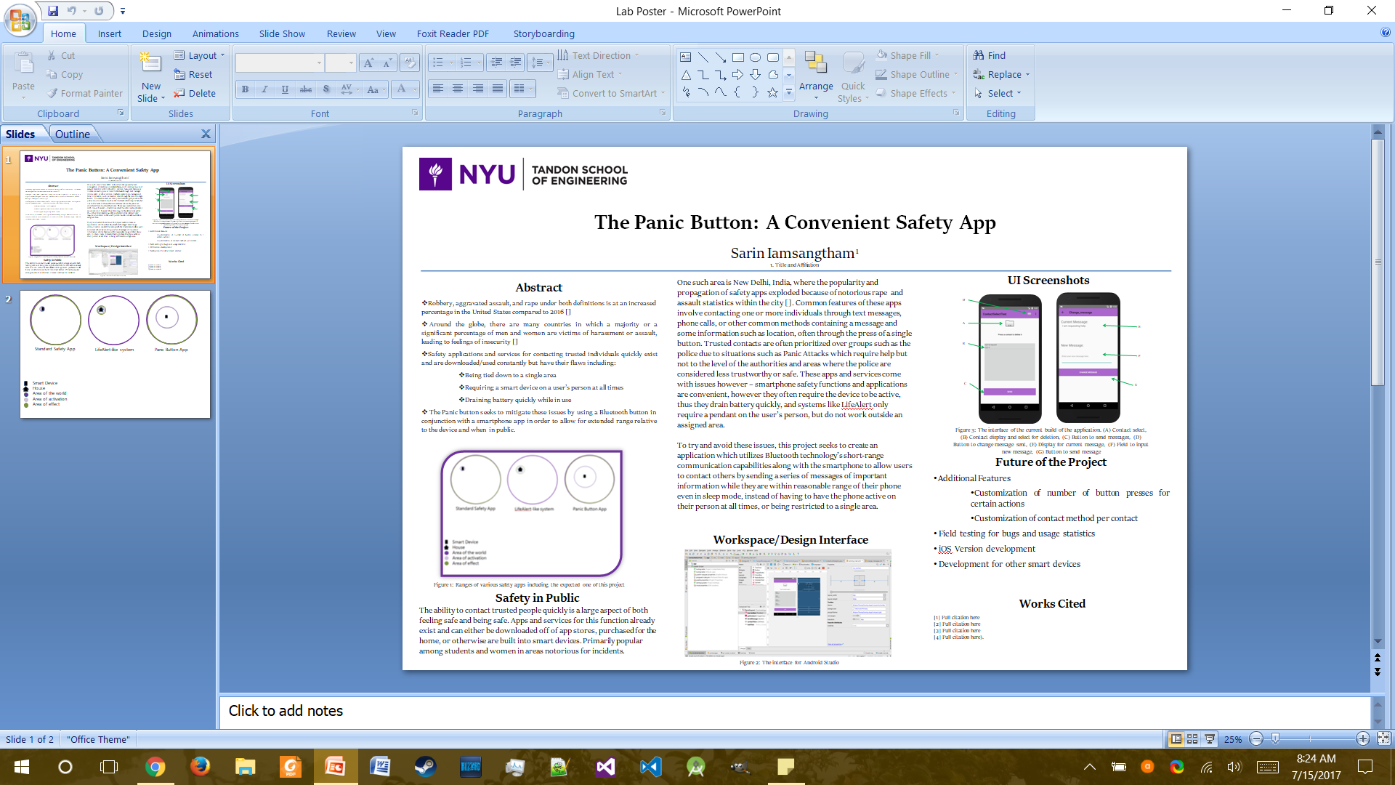
* July 15th 2017
  + Changed some parts of the poster again (~1 hour)
    - Added citations
    - Condensed more paragraphs into bulleted lists
    - 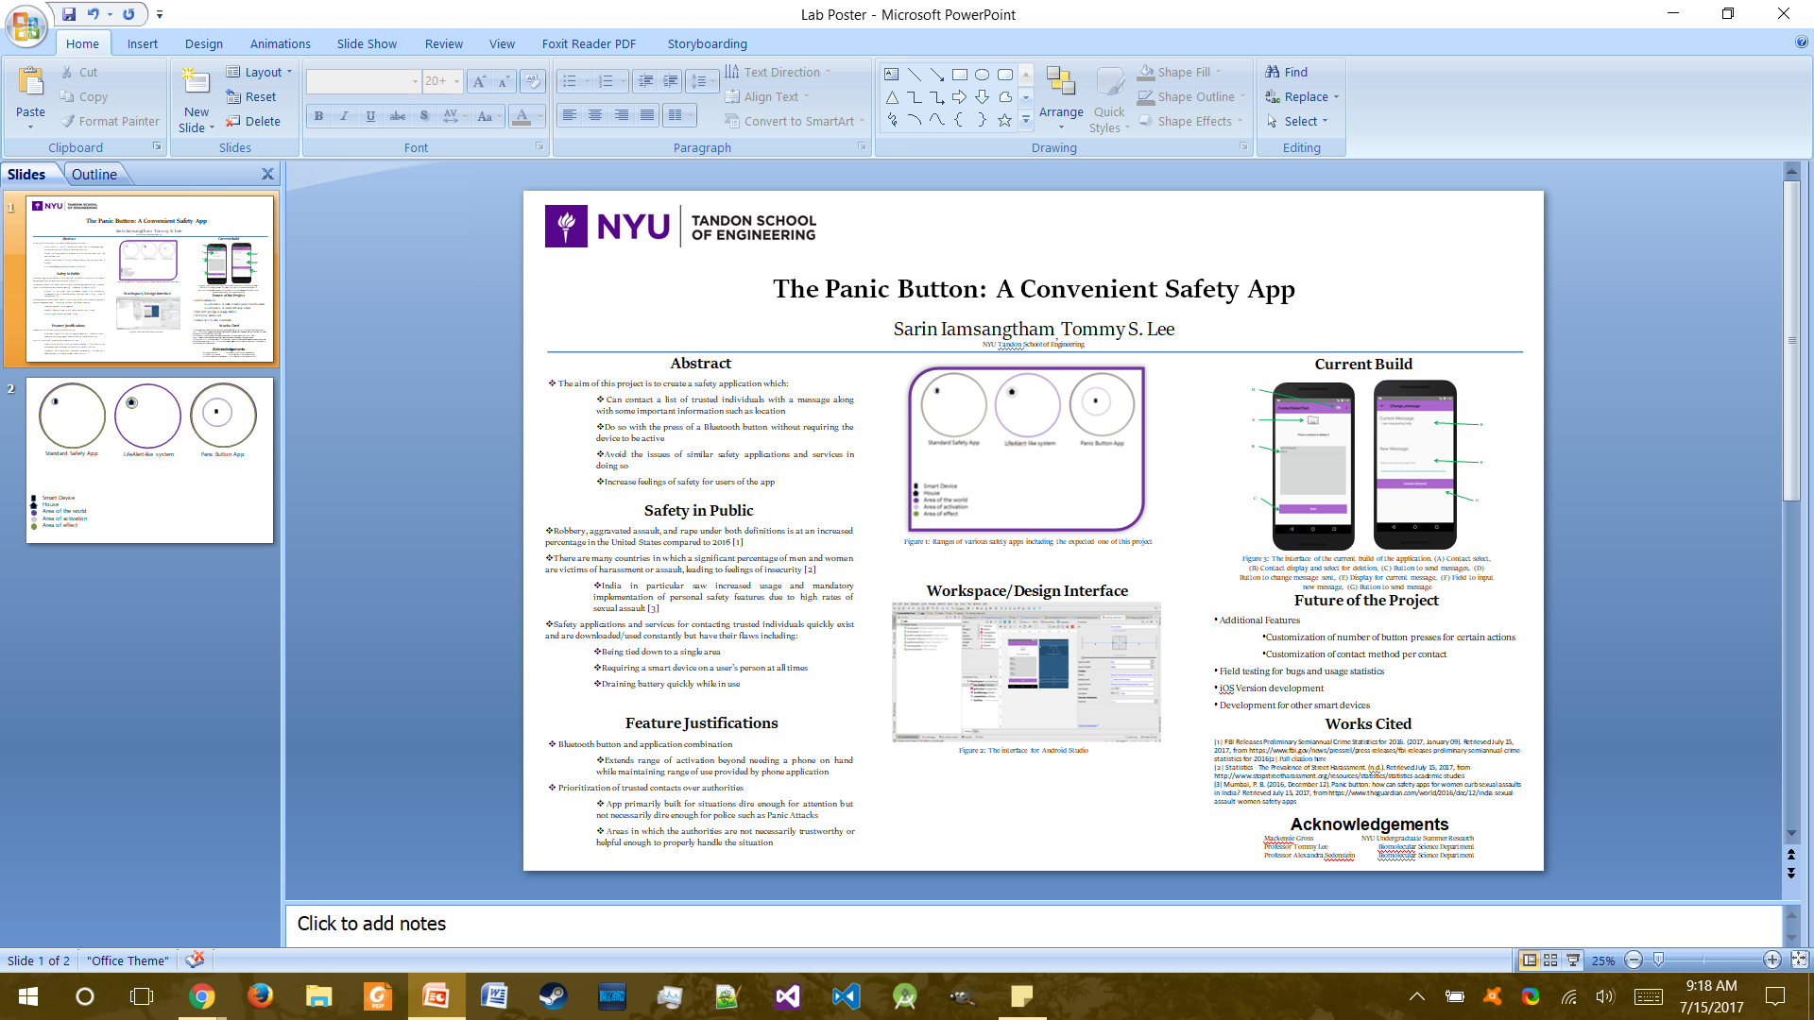
* July 17th, 2017
  + Considered next steps of the project (~0.5 hours)
    - Should really try and get location stuff up and running
    - Need to work on poster, the second WIP
    - Need to figure out how to have the app active in sleep mode if necessary
  + Found some articles to write about this week (~1 hour)
    - Internet of Things Becomes Next Big Thing
    - The Future of the Internet of Things
    - Okay, now I think I’m starting to actually run out of topics to write about.
  + Edited the poster a little more, submitted a draft for review (~1.5 hours)
  + Started WIP 2 (~1.5 hours)
  + Laid groundwork for location messages in the prototype (~2.5 hours)
    - Created flag for whether or not it should send an additional location message
    - Will add actual message implementation next time
* July 18th, 2017
  + OLW Check-in (~0.5 hours)
  + Finally able to implement last known location into the app (~2 hours)
  + Attended Wasserman Center presentation (~1 hour)
  + Tried to find Sidelstein for advice on the poster, but couldn’t find her (~0.5 hours)
  + Tried a new format for the poster anyway (~1.5 hours)
    - 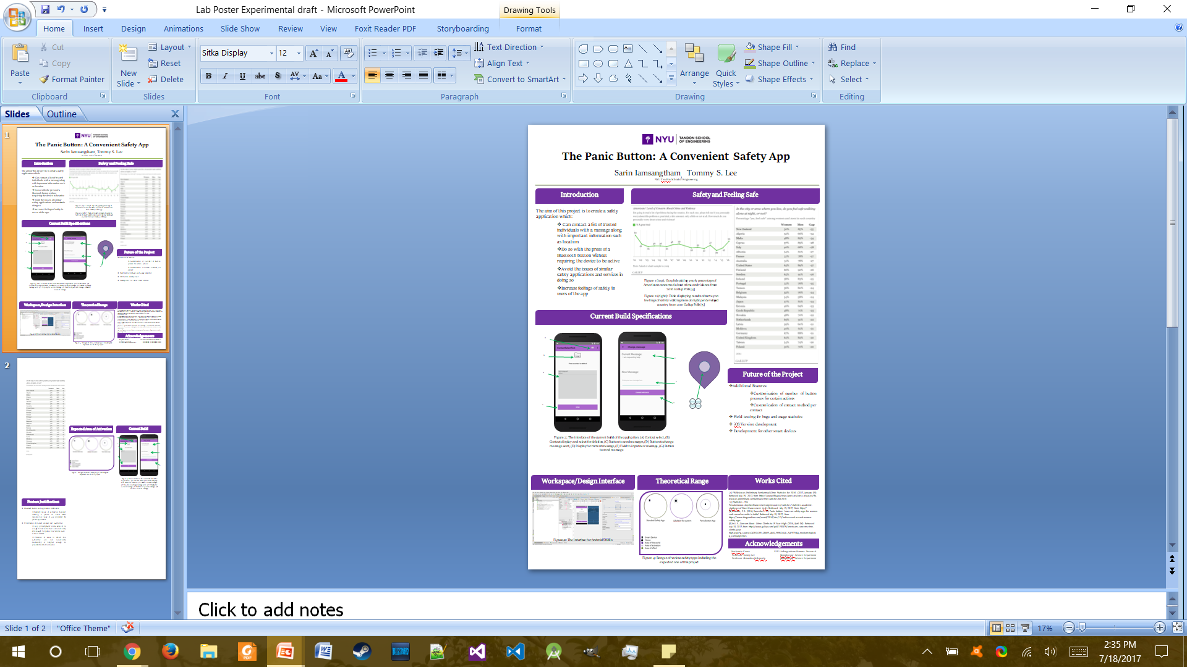
  + Wrote first article review for the week (~1.5 hours)
* July 19th, 2017
  + Worked on WIP 2 (~1.5 hours)
  + Worked on poster a bit more (~1.5 hours)
    - Mainly fonts and some rearrangement
    - 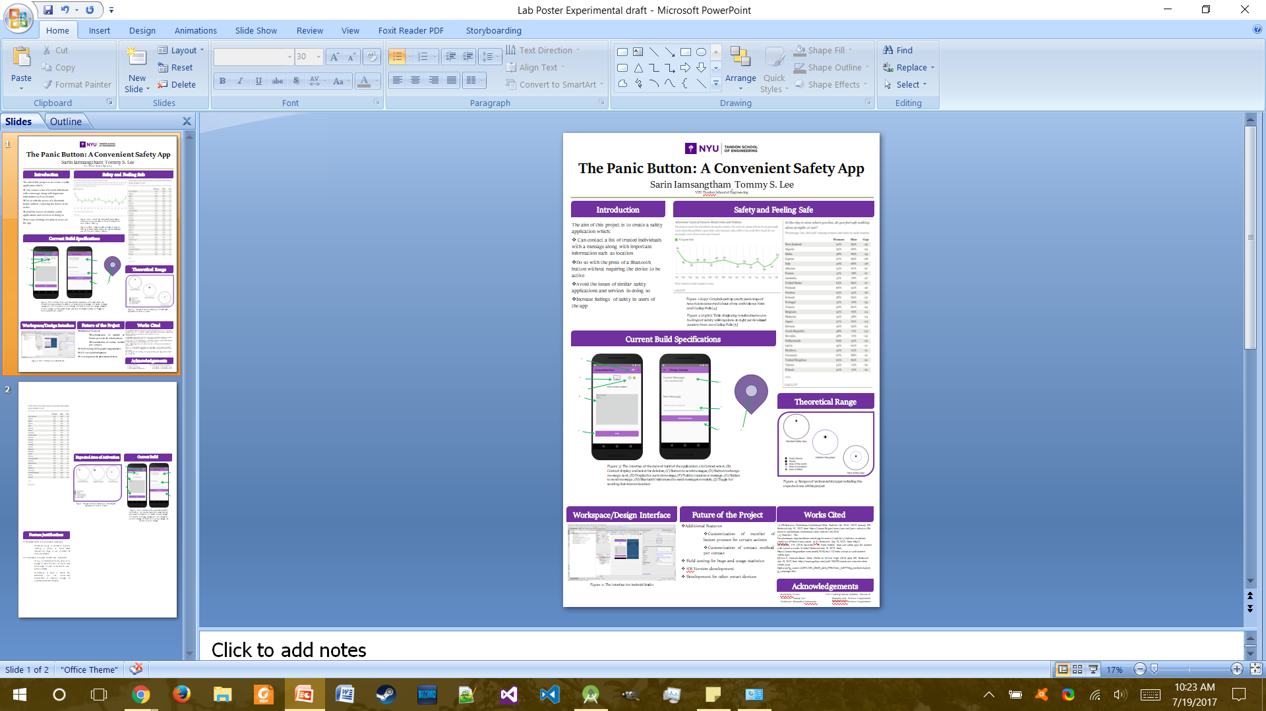
  + Waited for poster draft to print so I can look at it because these stupid printers don’t work for some reason I hate these printers so much (~1 hour)
    - Hasn’t actually printed by this time
  + Fixed some text inconsistencies in the prototype (~0.5 hours)
  + Mulled over/Brainstormed about whether or not I should restrict the volume-up trigger to if there’s a Bluetooth device connected (~1 hour)
    - Ultimately decided against it for additional functionality, but will need to add a warning to the app later on to compensate
  + Also did some more reading on how to do listen to volume up inputs while in sleep mode? (~1 hour)
    - <https://stackoverflow.com/questions/13357187/catching-key-presses-when-android-phone-is-in-deep-sleep-mode>
    - <https://stackoverflow.com/questions/13357187/catching-key-presses-when-android-phone-is-in-deep-sleep-mode>
    - Might not actually be possible with the current API documentation after all
  + Added option to clear all contacts in the dropdown menu in the toolbar of the prototype (~0.5 hours)
* July 20th, 2017
  + Thought about possible ways to have the app consume less battery (~0.5 hours)
    - Figure maybe a psuedo-lock where the screen’s just turned off but the app’s still active could be a solution?
    - Need to look more into this
  + Tried looking up if it was possible to have the screen off, that also might be impossible with the current APIs (~1 hour)
    - <https://stackoverflow.com/questions/9561320/android-how-to-turn-screen-on-and-off-programmatically>
    - <https://stackoverflow.com/questions/39530255/how-can-i-programmatically-turn-off-screen-in-android>
    - Also likely that any workaround solution would use more battery than if the device was actually in sleep mode
    - Maybe it is possible actually? Need to test it. <https://stackoverflow.com/questions/7924241/how-i-can-receive-hardware-key-events-in-sleep-mode>
  + Worked on poster a bit more (~1 hour)
    - Changed some font inconsistencies, messed with some alignment issues, but poster is mostly the same as last draft
    - Sent it in for another look-over, waiting on feedback
  + Worked on the Bluetooth Button test app again (~0.5 hours)
    - Found a way to get a temporary counter for a period of time, will need to implement it into the actual prototype somehow so I can have a warning press or an authority-calling button press or something like that.
  + Considered how to implement customization of the button-press timer (~0.5 hours)
    - Possible customization elements
      * Time the app will wait for the button presses
      * Number of button presses needed before time runs out to send the messages
      * Number of presses needed before time runs out to make the phone call to authorities or otherwise in addition to the messages
      * Might need to make this a separate menu in the toolbar
      * Need to establish defaults for each of these in case something goes amiss
      * Also need to establish caps so they aren’t ridiculous
  + Read about remote shutters again because the last time I tested them, it wasn’t registering the button corresponding to the enter key, but it did accept the Volume Up input button fine. (~0.5 hours)
    - Still says that the buttons are mapped to ENTER and VOLUME UP, so I don’t know what’s going on with this.
  + Actually tried it with the bluetooth button and all of a sudden it works for this now, which is odd since I remembered this not working the last time I tried it out. (~0.5 hours)
  + Synchronized the changed files to GitHub (~0.5 hours)
    - Still not sure how to really “read” github, but figured it out eventually.
  + Added the feature that prevents accidental presses of the button by forcing a second one or more within five seconds to the prototype (~0.5 hours)
    - Fixed up the second WIP to correspond to sudden changes as well
  + Practiced the WIP 2 presentation a bit (~1 hour)
  + Read the second article to write about this week (~1 hour)
  + Attended WIP presentations (~2 hours)
  + Wrote second article review (~0.5 hours)
* July 21st, 2017
  + Worked on poster some more, waiting on feedback (~2 hours)
  + Looked over prototype code again to check for errors, none found as of yet. (~1.5 hours)
    - Also added some more comments for documentation purposes
  + Found more formatting issues with the poster, fixed them up (~0.5 hours)
* July 23rd, 2017
  + Did some last adjustments to poster according to feedback, submitted it (~0.5 hours)
* July 24th, 2017
  + More thoughts on what to do next with the project this week (~0.5 hours)
    - Should get around to implementing the phone call, at least to some dummy number before thinking about allowing for customization
    - Wonder if battery optimization will be an issue too
    - Should probably have some way to customize button press threshold after implementing phone call
  + Waited on Android Studio to update (~15 minutes)
  + Had to restart Android Studio after a crash, which I didn’t realize was a crash until a while in (~15 minutes)
  + Was going to work on some new features, but ran into a new unintended behavior in which the onscreen button would instantly send the message(s) and dealt with it accordingly (~1 hour)
    - Tried for a bit to make it work like the other buttons, but figured that there probably should be a backup quick-send anyway so left it as is, but changed the label
  + Implemented rudimentary phone call functionality into prototype (~2 hours)
  + Tried to make it so you could pick a contact and make that your emergency contact on the same screen as the main activity, but eventually realized that it was very error-prone and had to undo the whole thing. (~2.5 hours)
    - Also finding it a bit hard to navigate my code now, considering a full cleanup at some point before presentation or just in general.
    - Considering just having another activity in the program for it, though maybe I’m having too many of those?
  + Worked on adding that new activity, got the class and the layout done (~0.5 hours)
* July 25th, 2017
  + Found some articles to write about, though took a little longer since I’m still running out of ideas on topics to search for (~1 hour)
  + OLW Check-in (~0.5 hours)
  + Read one article for the week (~1 hour)
  + Presentation (~1.5 hours)
  + Team Building Activity at Central Park (~4 hours)
  + Wrote review on article (~1 hour)
* July 26th, 2017
  + Waited on Android Studio updates (~0.5 hours)
  + Implemented rest of the minimum necessary for phone number selection (~4.5 hours)
    - Ran into a bug where the emergency number would reset on redownloading the app. Not sure why that happens, will need to look into it.
  + Fixed up the UI for the activity a bit, considering how to do the other parts (~0.5 hours)
  + Thought about if I should allow an emergency call even if no contacts are listed since the current implementation doesn’t allow for that. (~0.5 hours)
    - Unsure about this still
* July 27th, 2017
  + Continued thinking about letting users do an emergency call with no contacts put in for messages (~0.5 hours)
    - Decided against it for now if only because at that point you may as well just call the person, though will try and ask others about their opinions
  + Thought about what to actually do next in this project (~0.5 hours)
    - Should still do the button press customization thing as a separate activity
    - A help/how-to section wouldn’t hurt either honestly
    - Not sure how I should clean up the UI, maybe I should follow Google’s Material Design standards?
    - Should look into how to actually add like, version numbers to things and keep that updated.
    - Other than that, can’t think of too much else to add to this
  + Read about Material Design specifications (~0.5 hours)
    - <https://material.io/guidelines/material-design/introduction.html>
    - <https://developer.android.com/training/material/get-started.html>
    - Kind of going over my head right now actually
  + OLW Check in (~0.5 hours)
  + Some more UI meddling (~1 hour)
  + Started implementation of customizing button presses (~1.5 hours)
    - Really hope it’s not too much to deal with
  + Fixed that bug encountered yesterday, turns out onResume was implemented incorrectly (~0.5 hours)
  + Finally implemented the basic button-press customization stuff into the prototype, backed up the files (~1 hour)
  + Read the second article for this week (~1 hour)
  + Wrote about the second article, not really sure why it took me longer this time actually. (~1 hour)
* July 28th, 2017
  + Had to wait on a computer crash, restarted computer (~0.5 hours)
  + Still had to think about what to do next, since most of the major features of the app have been implemented by now (~0.5 hours)
    - I guess I could add something for customizing time to press buttons
    - A Help page would also be useful
    - Need to touch up the layout in some areas
  + Touched up the UI again in some areas (~0.5 hours)
  + Read about dialogs a bit, seems useful for the help screen (~0.5 hours)
    - <https://stackoverflow.com/questions/5810084/android-alertdialog-single-button>
    - <https://developer.android.com/guide/topics/ui/dialogs.html>
  + Started work on the help screen (~0.5 hours)
    - Wondering if I should have one for each activity instead of compiling into a single screen.
    - Probably a good idea.
  + Tried to work through an Android Studio crash because I thought I didn’t save my progress, but upon restart it turns out that I did (~0.5 hours)
    - Probably could’ve saved some more time by just outright restarting it in hindsight
  + Finished adding the first help screen to the main activity (~0.5 hours)
  + Tried implementing help button in other toolbars in activities but realized that I was working on the wrong set of files (which were wrong because I guess I put them into Github without thinking. Still do not know how that works.) (~0.5 hours)
    - Deleted all the duplicate files (thankfully I didn’t actually do other work on them (I hope))
  + Started work on the other help screens, but eventually realized that they were so simple that they probably didn’t need too much additional explanation (~0.5 hours)
    - Undid the work on them
  + Added option to customize the seconds until it decides to send the message or not (~1.5 hours)
* July 31st, 2017
  + Another thinking/brainstorming session on what to do next for this project (~1 hour)
    - These are getting harder each time because I’ve pretty much implemented most of the things I’ve wanted to for this app (which have been listed on the poster anyway)
    - I guess I could clean up the UI now
    - Something with Bluetooth Status? Doesn’t seem particularly necessary
    - Code cleanup? Seems okay for now but could use a go-over
    - I guess an actual launcher icon wouldn’t hurt either
    - I got nothing else
  + Looked through the UI code to see if I can adjust anything to make it look better (~0.5 hours)
  + Changed the UI for the button press customization a bit, and also updated some other UIs a little (~1.5 hours)
  + Tried implementing Cards into the layout, but kept getting layout issues and dropped the idea altogether for now (~1 hour)
  + More UI adjustments (~1 hour)
    - Tried to fix something with the contact toggle, but couldn’t get it to work
    - Added some more distinction between name and number in the list view
    - Lots of text box alignment
    - Other things I can’t think of right now
  + Added more comments to the code for better understanding (~0.5 hours)
  + Another look-over through the code for any glaring issues (~1 hour)
    - Can’t notice anything, wonder if somebody at the school can help me clean up the things I’ve missed with me.
  + Realized I was using GitHub wrong and deleted some files, resorted to the normal way of backing up files through a personal drive and a zip folder. (~0.5 hours)
* August 1, 2017
  + Another brainstorming session since I’m sort of reaching a point where anything I could do is sort of extra for the purposes of the basic app (~0.5 hours)
    - Could still use a launcher icon
    - A 3D Printed case for the button would be nice, if very much extra.
    - More UI Adjustments wouldn’t hurt I suppose
    - I can’t actually think of anything else
  + Looked up some articles to write about this week (~1 hour)
    - Tried to find more than two just in case, but just couldn’t think about what to actually look up
  + OLW check in (~0.5 hours)
  + Small code adjustment (~0.5 hours)
    - Fixed some variables in MainActivity with warnings from the compiler by individually defining instances in certain functions as opposed to having one overarching variable which might cause a memory leak.
  + Even more UI Adjustments (~2 hours)
    - This time adjustments were for adapting the layouts to different screen sizes, which is a detail I seemed to have completely overlooked in previous weeks.
    - Some windows still have issues adjusting to larger or smaller screen sizes than the test screen, will need to look farther into this
  + Another code adjustment (~0.5 hours)
    - Found an error where if android version was such that it didn’t need any permission checks, it would send a message out on one press of Volume Up instead of the specified number each time
    - Also found typos/warnings in other activities. Dealt with most of them to clean up the code a bit.
  + Made an icon for the app finally (~0.5 hours)
    - Used the built-in image asset maker
    - <https://developer.android.com/studio/write/image-asset-studio.html>
  + Read the first article, but a lot of it kind of went over my head so I guess I’m gonna have to reread some parts (~1 hour)
  + Reread article, wrote about it (~1 hour)
* August 2, 2017
  + Tried finding measuring tape again, still couldn’t find any for whatever reason (~0.5 hours)
  + Looked over the lab notebook and made sure everything was in order (~0.5 hours)
  + Looked over the layout again to see if anything could use adjustments (~2 hours)
    - Adjusted the elevation of some elements
    - Tried fixing some layout issues
  + Thought about if I could sort the contact list alphabetically and realized that while it was trivial to sort the namelist, getting it to also match with the number list would be a little more difficult. (~0.5 hours)
  + Did some research into improving app security (~0.5 hours)
    - SharedPreference stuff is already pretty safe, so it’s fine keeping contact info in there for now
    - <https://stackoverflow.com/questions/9244318/android-sharedpreference-security>
    - <https://developer.android.com/training/articles/security-tips.html>
  + Read about cryptography measures as they might be useful as a secondary measure of ensuring privacy in the app (~0.5 hours)
    - There is an in-built method, but I don’t know how it exactly works yet or how I would go about implementing it into the app
    - Methods through javascript also exist, but I’m unfamiliar with implementation of such
  + Created more image resources to replace some of the less aesthetically pleasing ones in the app (~ 1 hour)
    - 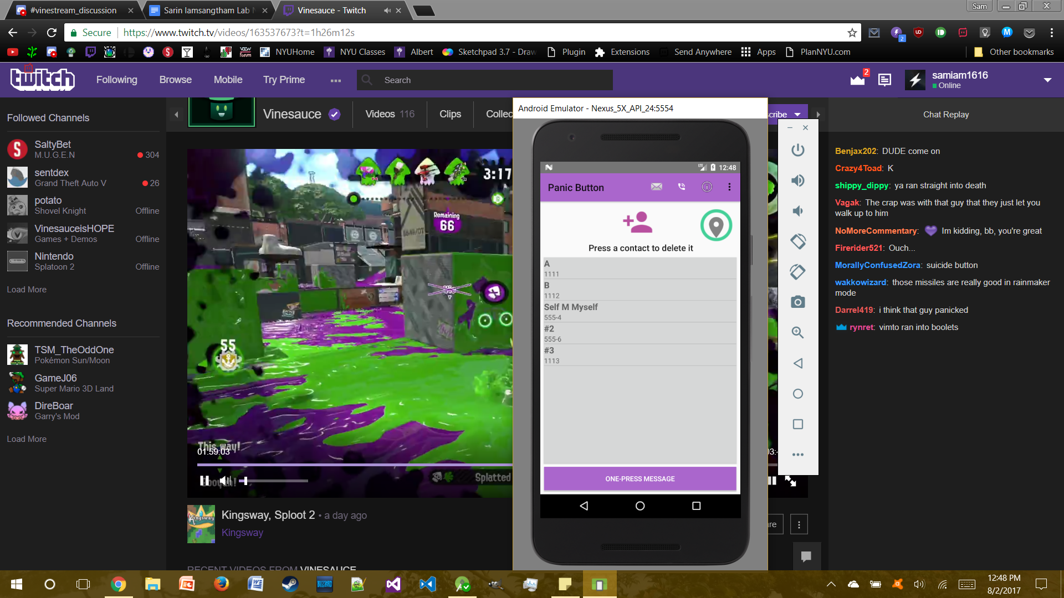
  + Talked about the next steps of the project with somebody, got some interesting advice in general, but nothing particularly specific to the project unfortunately (~0.5 hours)
  + More layout fixes and adjustments to text sizes according to compiler warnings (~0.5 hours)
* August 3rd, 2017
  + Coordinated some invitations to friends and family to drop by the presentation tomorrow (~0.5 hours)
  + Did some tinkerCAD tutorials to prepare for some 3D Printing possibly (~1 hour)
    - Both in-browser and a video
    - <https://www.youtube.com/watch?v=MwjWT-EvKSU>
  + OLW Check-in (~0.5 hours)
  + Looked at some TinkerCAD examples to see what’s possible with the software and also tried seeing if I could fake a sleep-mode functionality in Android Studio by having the activity run on top of the lock screen while it’s active? (~0.5 hours)
    - Determined that it was more than possible to do what I’m planning with TinkerCAD
    - Sleep-mode functionality still kind of iffy
      * <https://stackoverflow.com/questions/3629179/android-activity-over-default-lock-screen>
      * <https://stackoverflow.com/questions/3793221/how-to-display-activity-when-the-screen-is-locked>
      * <https://stackoverflow.com/questions/14352648/how-to-lock-unlock-screen-programmatically>
  + Did some work on modeling a case for the button using tinkerCAD (~1.5 hours)
    - Sort of wish I had done this earlier actually
  + More work on the model so it prints marginally easier along with setup in Cura (~1 hour)
  + Found a way for the app to be “above” the lock screen if the app was active before it was put to sleep, thus allowing for a bit of a pseudo-sleep-mode functionality (~0.5 hours)
    - All Toasts and notification boxes (not notifications themselves) aren’t visible in this state.
    - Also not sure about any possible repercussions
  + Tried finding an unused printer to start the printout with, but all of them were taken and I have no idea if I can even reserve a printer or call dibs on using one next, so I figure “screw it, may as well just print it tomorrow” since it’s estimated 3 hours for the case to print and I come in pretty early anyway, though that leaves me with little margin for error before the presentation. (~0.5 hours)
  + Read the second article for the week
  + Went to go look at the poster for a bit (~0.5 hours)
  + Wrote article review (~1 hour)
* August 4th, 2017
  + Checked with people coming to the event just to make sure everything is in order, also double checked with people who said they weren’t sure they could come (~0.5 hours)
  + Added some stuff to destroy the window flags on activity deletion just in case, also fixed some minor UI issues left over from all those other UI retooling times (~0.5 hours)

* + Ran some trials with the button and an actual phone while waiting for MakerSpace to open (~0.5 hours)
    - Found out that you need to press the second button on the button to actually wake it up first, then press the main button, will need to tell user this or adapt button at least to indicate what needs to be done.
  + Set up the 3D print and observed it for a bit to make sure it didn’t outright break in the first half hour. (~1 hour)
    - Hopefully it doesn’t break within the next few hours
  + Thought about how to structure my elevator pitch during the presentation (~0.5 hours)
    - Figured that I should be able to explain what my project is with relative ease, though I may need to introduce at least the concept of bluetooth if asked to go through the project
  + Finally tested the range of the bluetooth button in which it works with the app (~0.5 hours)
    - Found the range to be at least 70 feet (21.336 m), though this is not the best measurement due to running out of room and measuring tape to accurately test it with
    - Test was done in the Makerspace using my phone and a standard bluetooth shutter, rather wide open space though some machines and whatnot were in the path I tested
      * Interference or even possible boosting from other machines possible, need to have a more rigorous test done but good to have a statistic for now for the presentation
  + Practiced the elevator pitch a bit more (~1 hour)
    - Thinking about what to say in certain situations
    - Trying to solidify reason of importance, probably something like improving feelings of safety through an easily accessible app
  + Spent some time peeling the plastic off the print (~1 hour)
  + Presentation setup (~1 hour)
  + Presentation (~2 hours)
* August 7th, 2017
  + At the presentation, the button wasn’t working for whatever reason, decided to do some testing with it today to see what was up (~0.5 hours)
    - Button works now, so I guess it was just interference from the truckload of BT-enabled devices at the event.
  + Was looking at how to possibly reduce the effect of interference on the button/BT devices, didn’t find anything particularly helpful (~0.5 hours)
    - <http://www.goldtouch.com/stop-bluetooth-interference-messing-devices/>
    - Figure that there are a decent-sized chunk of situations which would make for interference, so might be good to look into more.
  + Worked on the final WIP (~3.5 hours)
  + Started archiving the project in the Drive folder (~0.5 hours)
  + Additional 2 hours from extra hours stockpiled on previous days.
* August 8th, 2017
  + Looked up some articles to write about this week only to realize that there are no article reviews due this week (~0.5 hours)
  + Looked into how to optimize code a little and do some version control in android studio (~1 hour)
    - <https://developer.android.com/studio/publish/versioning.html>
    - <https://developer.android.com/studio/build/shrink-code.html>
    - Will try and update current project to best of my ability based on this
  + OLW Check in (~0.5 hours)
  + Renamed the project into “Panic Button” through refactoring, changed up some code to make the sleep mode function work since it broke again at some point (~1 hour)
  + Started writing user guide for the button for the archive (~0.5 hours)
  + Looked back at notebook to see what changes I’ve made to the project since WIP 2 (~0.5 hours)
  + Worked on WIP 2 some more (~1 hour)
  + Updated some of the files in the archive (~0.5 hours)
  + Additional work on the archive’s Manual (~1 hour)
  + Additional 30 minutes from previously stockpiled hours

* August 9th, 2017
  + Thought about what I can do with the last few days of the project (~0.5 hours)
    - Figure that everything I wanted to accomplish with the base app and even some additional features have already been done
    - I guess some more UI Tweaking wouldn’t hurt
    - May just want to focus on the WIP and archiving the project for the rest of the week
    - Should probably ask about the payment situation for this last week too since the previous email claimed that the last week was the last pay period.
  + Checked out the xml files to see what could use a touch-up (~0.5 hours)
    - Maybe the customize button presses window could use a better layout
  + Tried to change up the button press customization layout a little (~1.5 hours)
    - Ultimately ended up changing very little, and still can’t figure out why it goes crazy on smaller screens if I change the layout from the current one
    - Other layouts work fine if the screen size is switched
    - At least some more constraints were defined
  + OLW Check in (~0.5 hours)
  + Worked on the sendoff note for the archive (~0.5 hours)
  + Worked on WIP3 more (~1.5 hours)
    - Mostly changing up semantics and some of the visuals
  + Worked on that documentation/manual some more (~1 hour)
    - Updated some wording, added a few things to keep note of, and added a misc section for some stuff which could use some explaining
  + Additional hour from previously stockpiled hours
* August 10th, 2017
  + Practiced WIP3 in head a whole bunch because I was stuck at Penn Station thanks to some presumed drunkard on the tracks at 14th street, and everybody being promptly ejected off the 1, 2, and 3 trains at once. (~1 hour)
    - Might need to do some more editing before it sounds right
  + Worked on WIP 3 some more (~1.5 hours)
  + Tried looking for professor Seidenstein to ask about why there wasn’t an OLW today, but couldn’t find her (~0.5 hours)
  + More WIP 3 work (~0.5 hours)
  + Waited for updates to Android Studio (~0.5 hours)
  + Looked over and fixed some more code, adding more comments and touching up some areas where things could’ve been done a little better (~1 hour)
  + One last practice for WIP 3 (~0.5 hours)
  + Fixed up the Panic Button Case model (~0.5 hours)
    - Made it slightly larger, fixed an issue where there actually was no hole
  + WIP 3 Presentation (~1.5 hours)
* August 11th, 2017
  + Made sure everything was backed up correctly in the archives (~1 hour)
  + Waited for presentations to start but realized I was an hour early (~0.5 hours)
  + Looked at app again to see if there were any more possible issues (~0.5 hours)
    - Couldn’t find anything
  + Attended final presentations (3 hours)
  + Other 2 hours from extra logged hours